CONTENT PAGE

1. ACKNOWLEGEMENT 1

2. ABSRACT 2

3. INTRODUCTOIN 3

4. PROJECT AIMS AND OBJECTIVES 4

5. BACKGROUND OF PROJECT 5

6. SOFTWARE NAD HARDWARE REQUIREMNETS 7

7. MODULES OF THE PROJECT 9

8. FEATURES OF MODULES 10

9. IMPORTANT SOURCE CODE 12

10. MAIN PROGRAM SOURCE CODE 13

11. TESTING OF PROGRAM 16

12. FUTURE SCOPE 24

9. REFFERENCE 25

**ACKNOWLEGEMENT**

We take this occasion to thank God, almighty for blessing me with his grace and taking my endeavor to a successful culmination. I extend our sincere and heartfelt thanks to my esteemed guide, RANJEET GUPTA, for providing us with the right guidance and advice at the crucial junctures and for showing me the right way. We also take this opportunity to express a deep sense of gratitude to JAGRAN PUBLIC SCHOOL. We would like to thank my teacher and family for the support and encouragement they have given us during the course of our work.

**ABSTRACT**

Library Management System is a system which maintains the information about the books present in the library, their authors, the members of library to whom books are issued, library staff and all. This is very difficult to organize manually. Maintenance of all this information manually is a very complex task. Owing to the advancement of technology, organization of a Library becomes much simple.

The Library Management has been designed to computerize and automate the operations performed over the information about the members, book issues and returns and all other operations. This computerization of library helps in many instances of its maintenances. It reduces the workload of management as most of the manual work done is reduced.

**INTRODUCTION**

The project titled Library Management System is library management software for monitoring and controlling the transactions in a library. The project “LIBRARY MANAGEMNET SYSTEM” is developed in python as well as MYSQL, which mainly focuses on basic operations in a library like adding new member, new books, and updating new information, searching books and members and facility to borrow and return books.

“LIBRARY MANAGEMENT SYSTEM” is a windows application written in 64 bit windows operating systems. Our library software is easy to use for both beginners and advanced users. It features a familiar and well thought out, an attractive user interface, combined with strong searching insertion and reporting capabilities.

**PROJECT AIMS AND OBJECTIVES**

The project aims and objectives that will be achieved after completion of this project are discussed in this subchapter. The aims and objectives are as follows:

• Adding books, user details, return details.

• A search column to search availability of books.

• Facility to update or delete required book.

• Students can take book.

• Users information details.

• Maintenance of library digital.

#### **BACKGROUND OF PROJECT**

E-Library Management System is an application which refers to library systems which are generally small or medium in size. It is used by librarian to manage the library using a computerized system where he/she can add new books, videos and Page sources.

Books and student maintenance modules are also included in this system which would keep track of the students using the library and also a detailed description about the books a library contains. With this computerized system there will be no loss of book record or member record which generally happens when a non- computerized system is used.

All these modules are able to help librarian to manage the library with more convenience and in a more efficient way as compared to library systems which are not computerized.

|  |  |
| --- | --- |
| PROCESSOR | INTEL CORE PROCESSOR OR BETTER  PERFORMANCE |
| OPERATING  SYSTEM | WINDOWS VISTA ,WINDOWS7, window 8,window 10 |
| MEMORY | 1GB RAM OR MORE |
| HARD DISK SPACE | MINIMUM 3 GB FOR DATABASE USAGE FOR  FUTURE |
| DATABASE | MY SQL |

**SOFTWARE AND HARDWARE**

**REQUIREMNETS**

**SOFTWARE:-**

* Operating system- Windows 7 is used as the operating system as it is stable and supports more features and is more user friendly.
* Database MYSQL-MYSQL is used as database as it easy to maintain and retrieve records by simple queries which are in English language which are easy to understand and easy to write.

**HARDWARE :-**

Intel core i5 2 generation is used as a processor

because it is fast than other processors a provide

reliable and stable and we can run our pc for longtime.

By using this processor we can keep on developing our

project without any worries.

➢ Ram 1 GB is used as it will provide fast reading and writing capabilities and will in turn support in processing.

**MODULES OF THE PROJECT**

1. Bookdetails
2. Bookuser
3. Issuebook

1. Main function test

**FEATURES OF MODULES**

A MODULE IS A PYTHON OBJECT WITH ARBITRARILY NAMED ATTRIBUTES THAT YOU CAN BIND AND REFFERENCE.

YOU CAN USE ANY PYTHON SOURCE FILEAS A MODULE BY EXECUTING AN IMPORT STATEMENT IN SOME OTHER PYTHON SOURCE FILE.

EXAMPLE:- IMPORT (MODULE NAME)

IN LIBRARY MANAGEMENT SYSTEM WE USE 3 MODULE FIRST IS BOOKDATAIL, SECOND BOOKUSER AND LAST ISSUEBOOK.

ALL MODULE CONTAIN UPDATE, DELETE, ADD, SHOW DATA .

WE CAN IMPORT IT AS SHOWN NEXT PAGE.

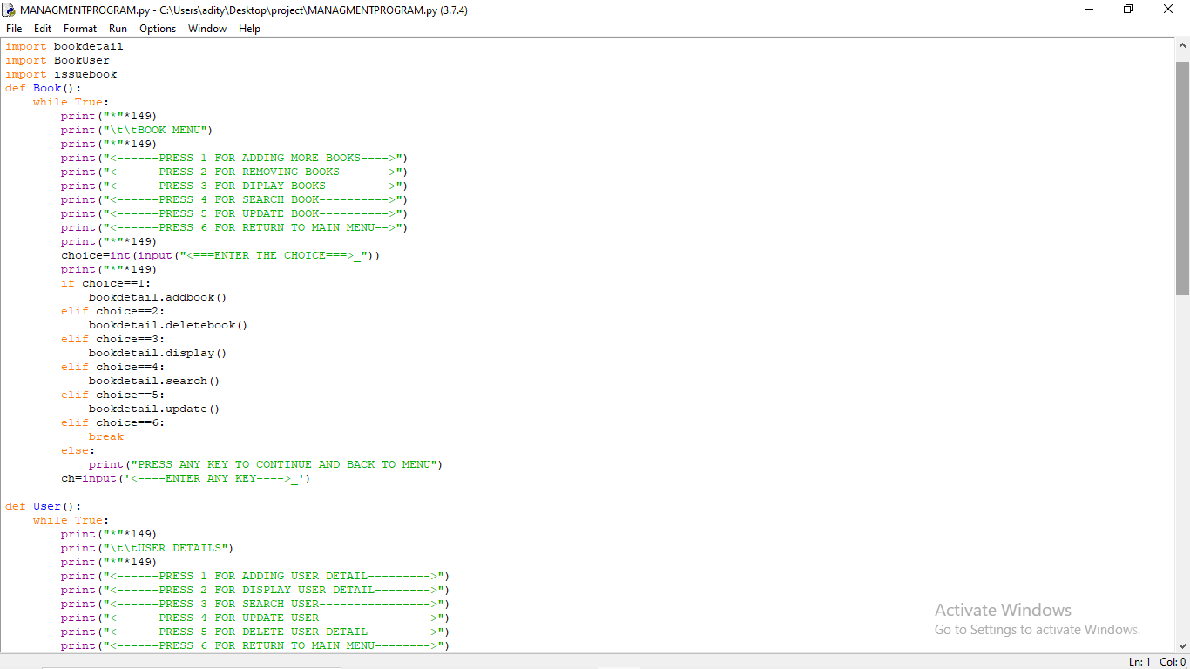

**IMPORTANT SOUCRE CODE**

**1.CONNECTION WITH MYSQL**

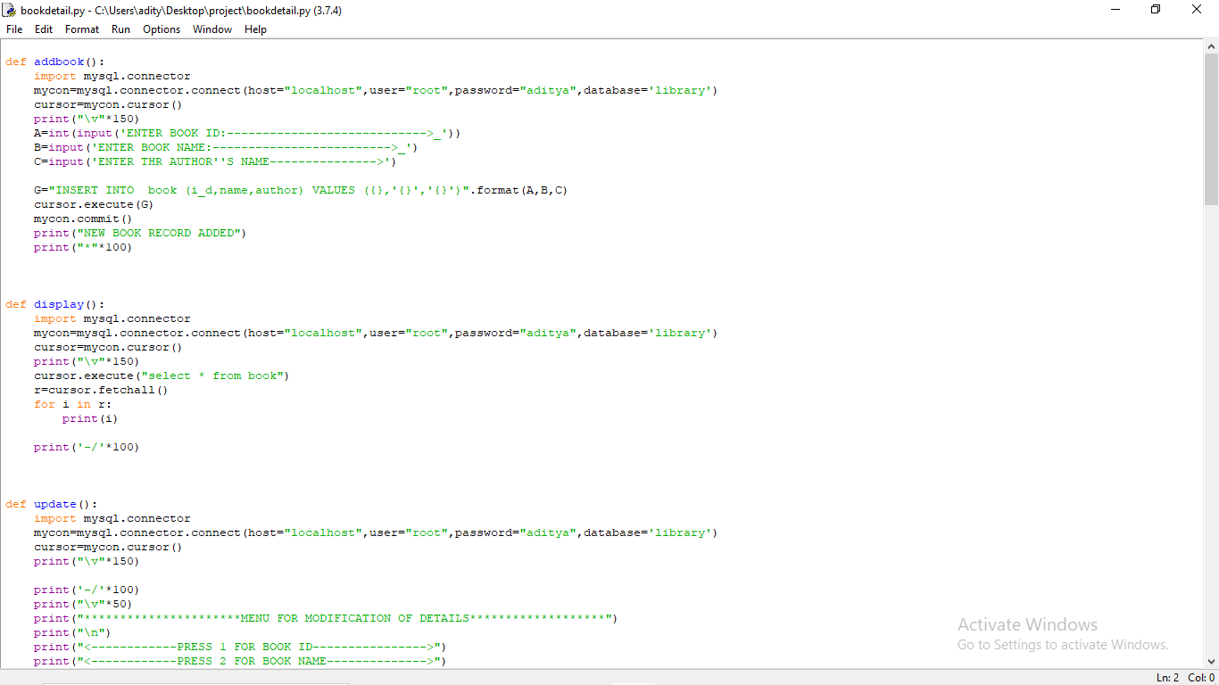**2. FUNTION USE:-**



**MAIN PROGRAM SOURCE CODE**

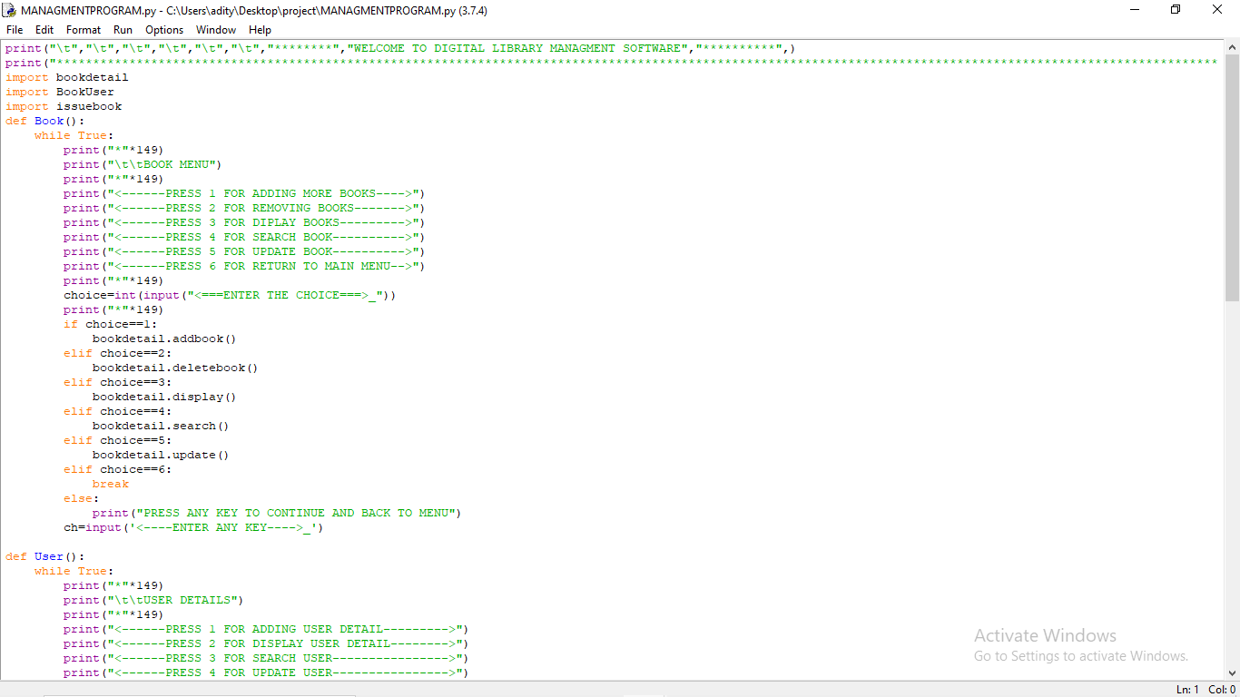

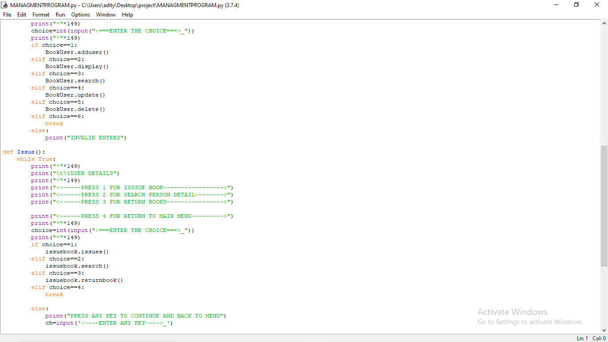

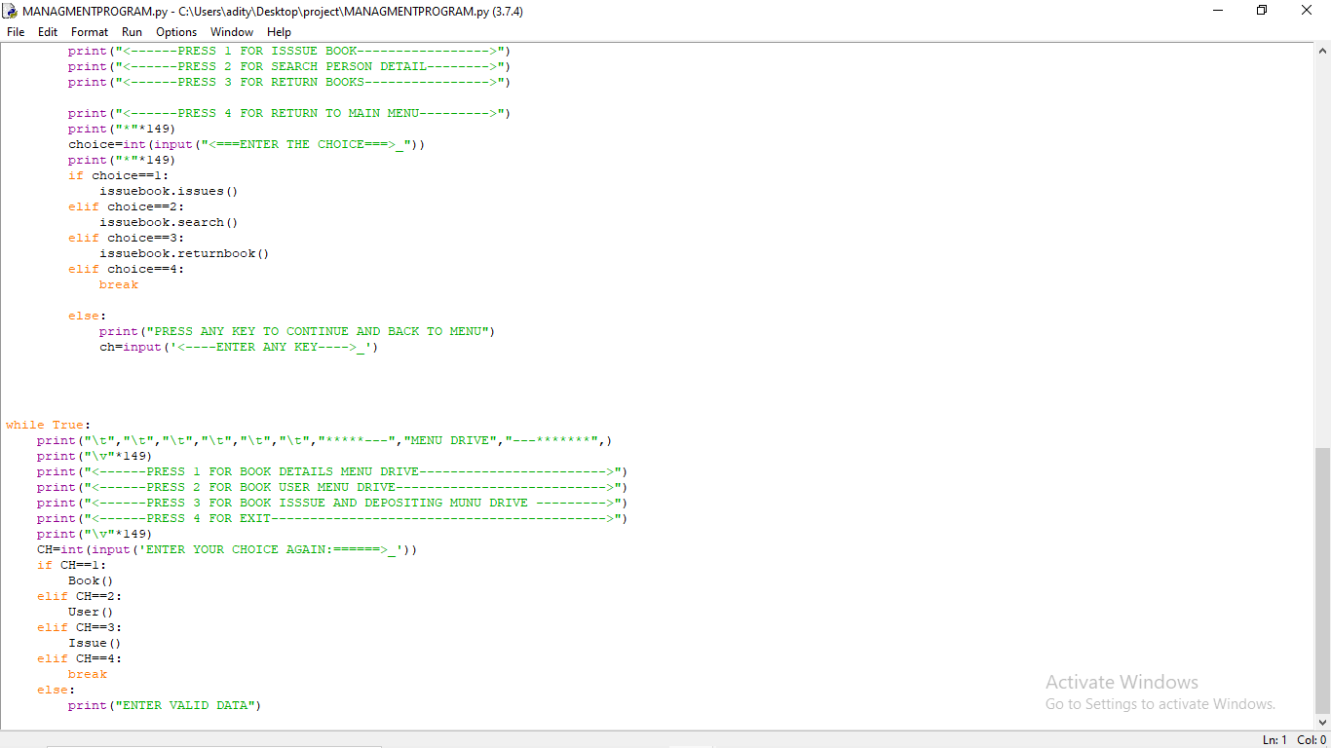 **TESTING OF PROGRAM**

**FOR BOOKDETAIL:-**

1. **DISPLAY OF BOOK**

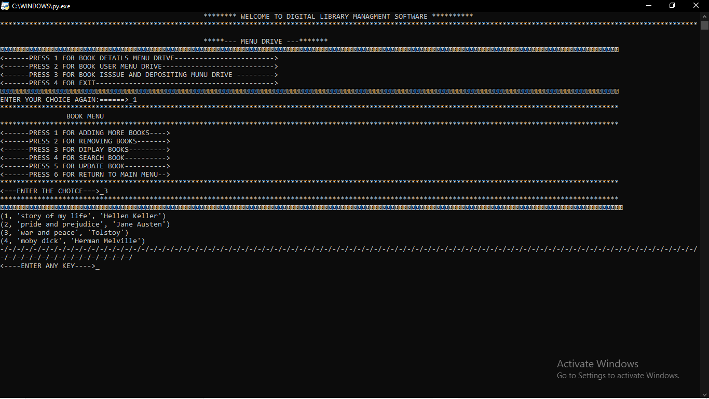

1. ADDING BOOK TO LIBRARY

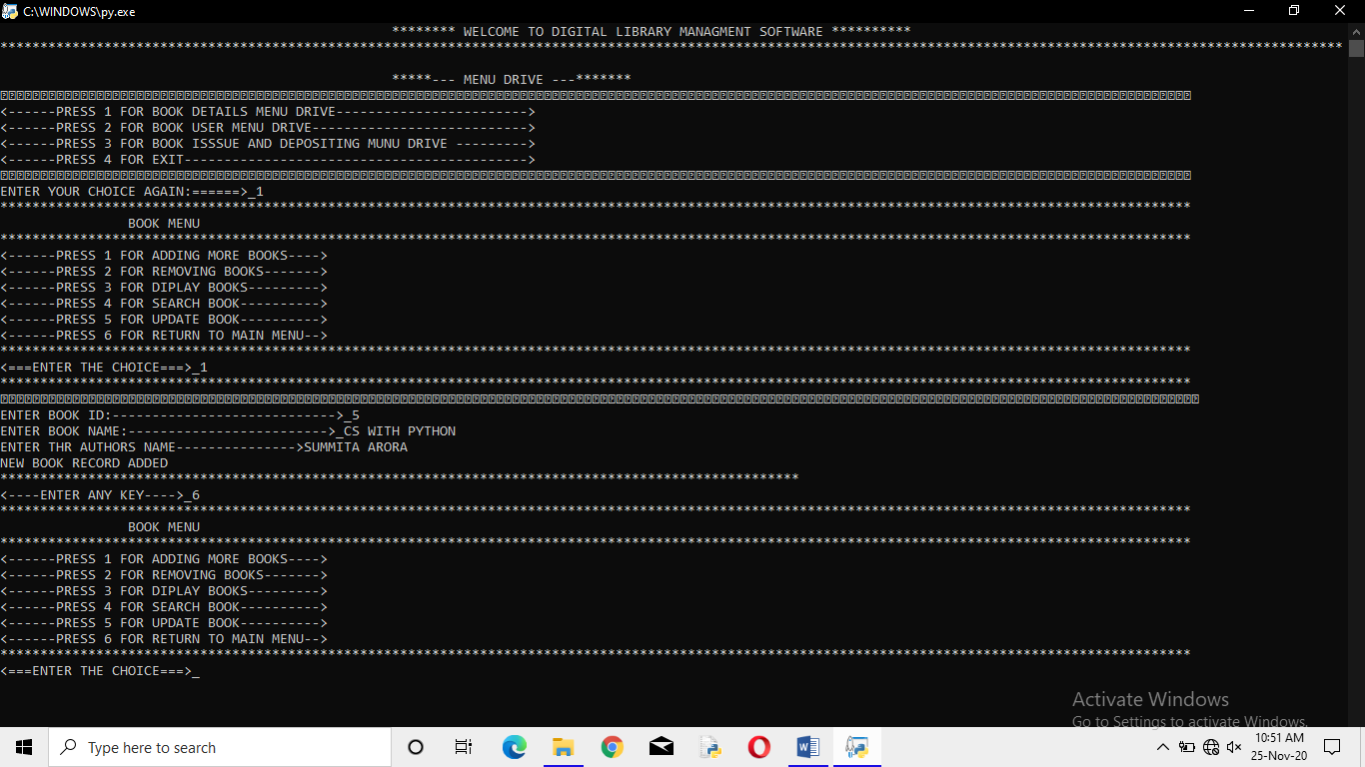

1. REMOVING OF BOOK

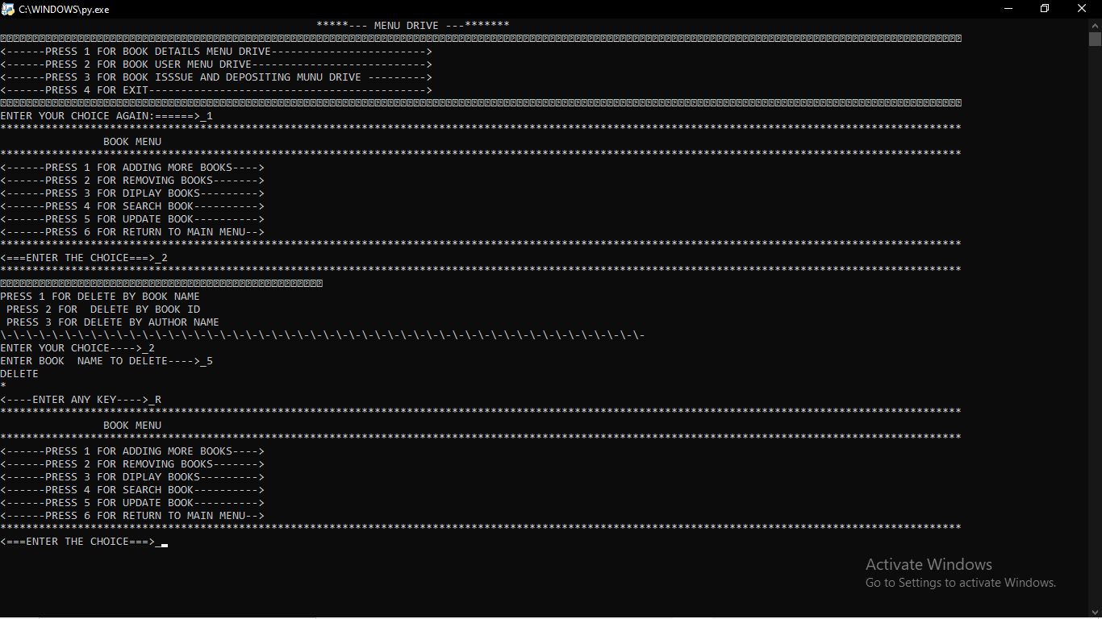

1. SEARCHING OF BOOK

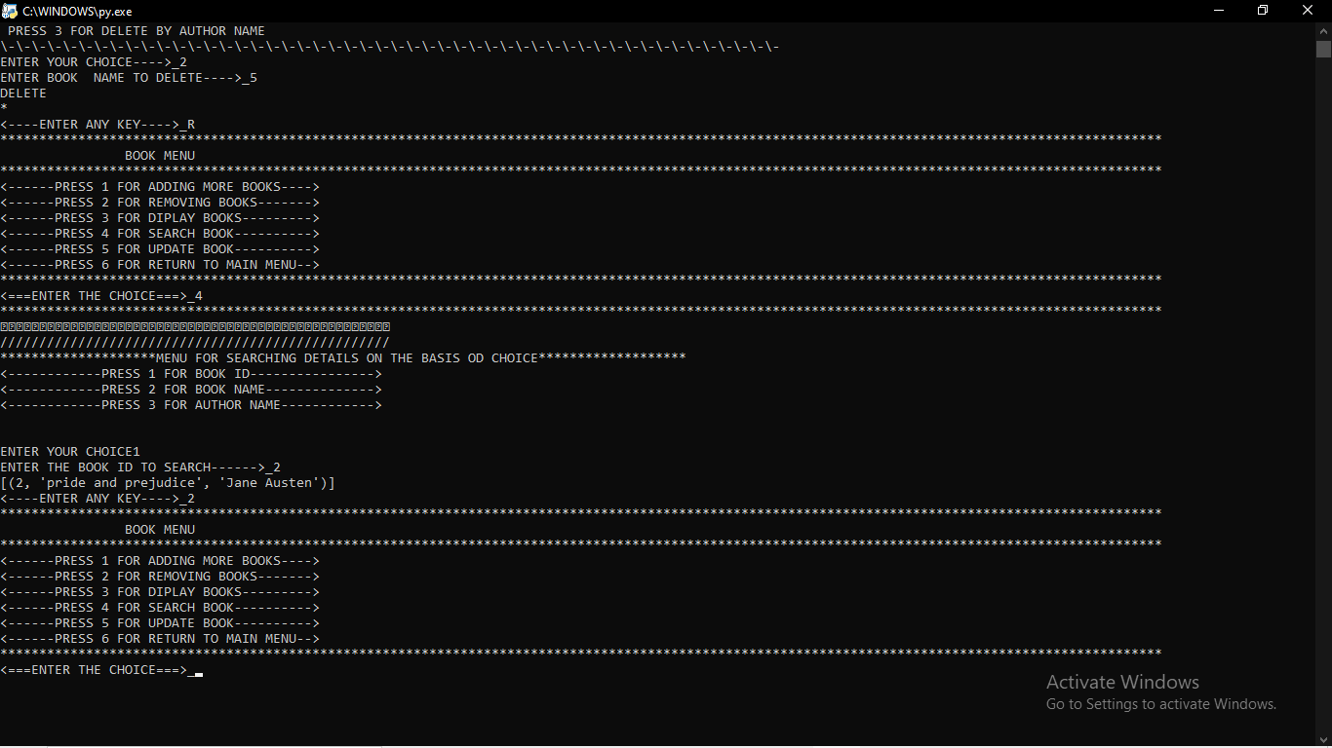

**FOR BOOKUSER:-**

1. **DISPLAY USER**

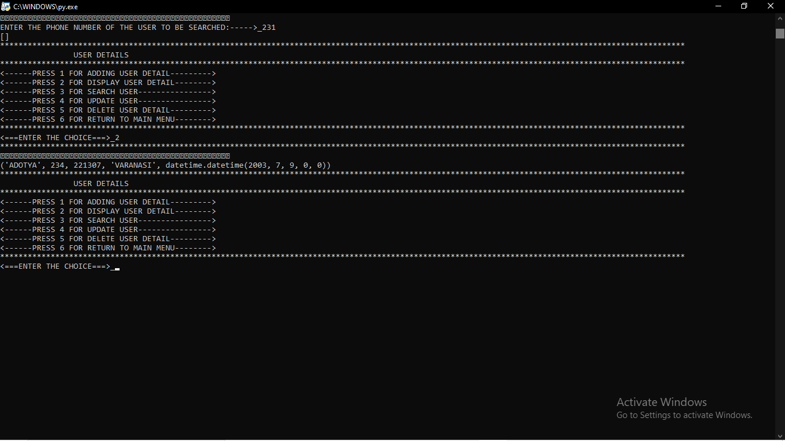

1. **ADDING USER**

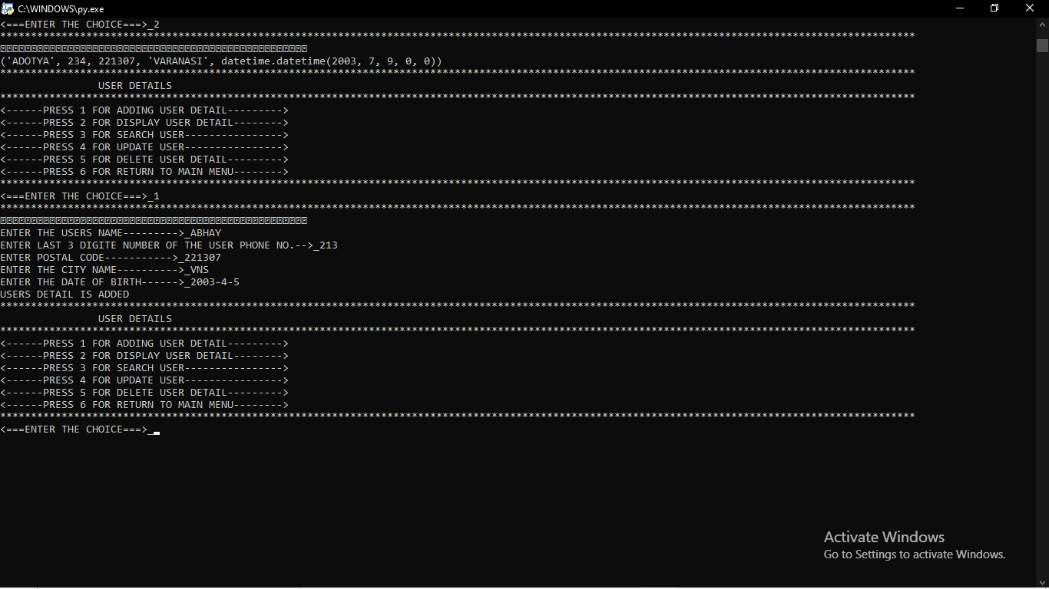

1. **SEARCH USER**

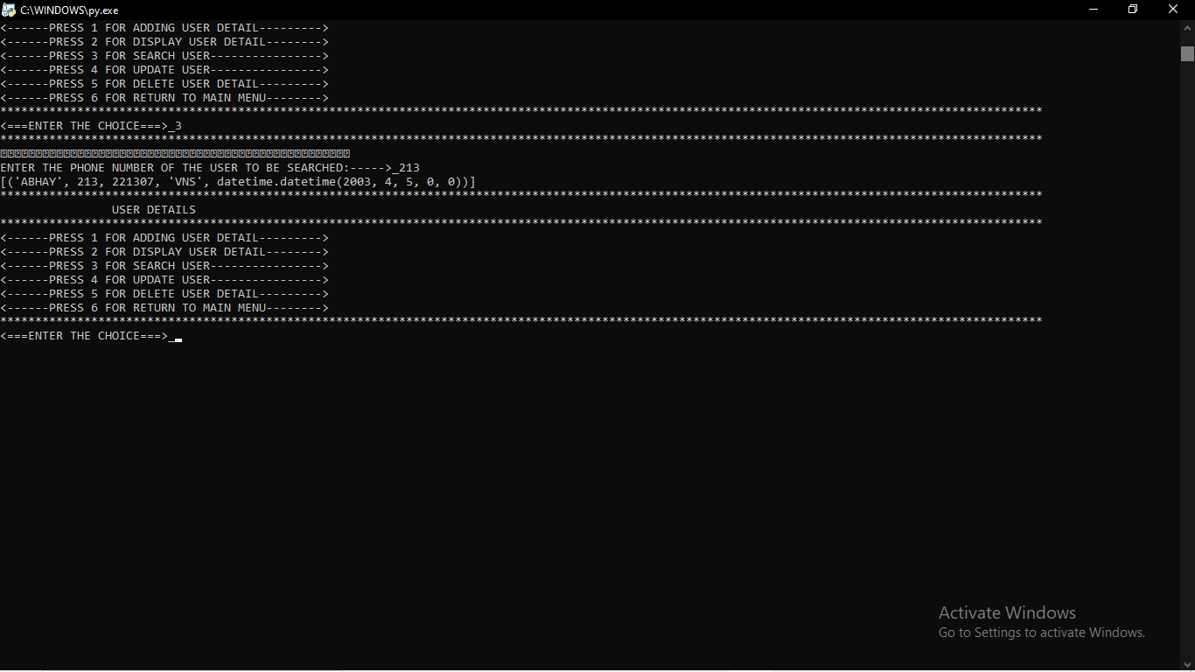

**FOR ISSUE:-**

1. **ISSUE BOOK**

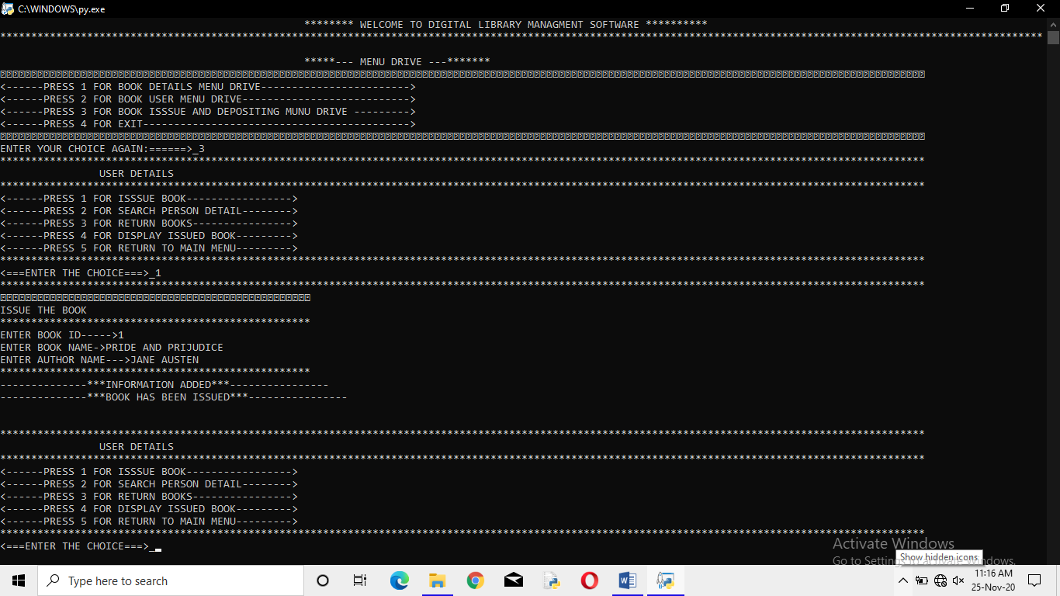

1. **DISPLAY ISSUE BOOK**

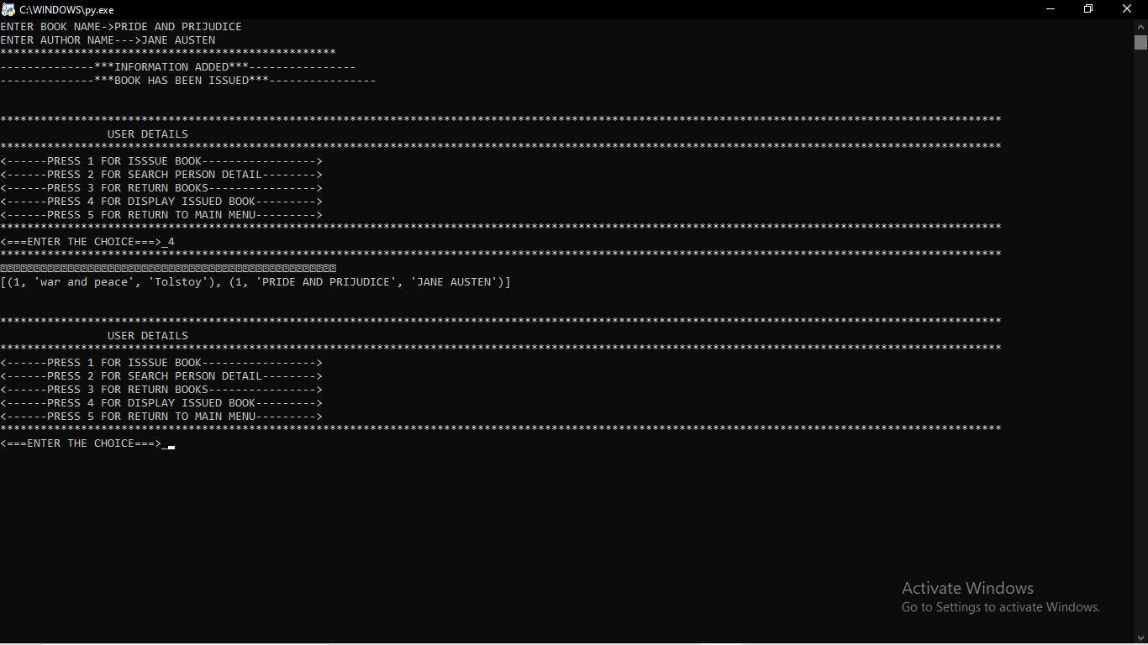

**FUTURE SCOPE**

There is a future scope of this facility that many more features such as online lectures video tutorials can be added by teachers as well as online assignments submission facility, a feature Of group chat where students can discuss various issues of engineering can be added to this project thus making it more interactive more user friendly and project which fulfills each users need in the best way possible,

REFERENCES

• WWW.w3SCHOOLS.COM

• WWW.academia.COM

• FROM CLASS 12 PYTHON BOOK (COMPUTER SCIENCE WITH PYTHON BY SUMITA ARORA}